* **Stock Management: -**
* Click on stock management module.

**1. Stock Report:**

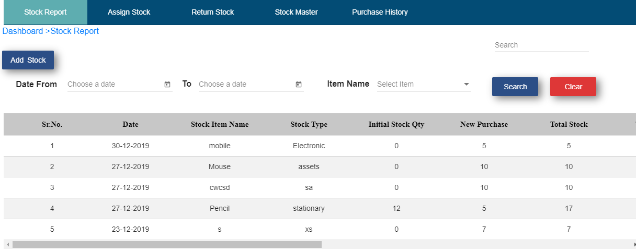

* Click on add stock.
* Enter stock item name.
* Select date.
* Enter stock type.
* Enter new purchase.
* Enter amount.
* Click on create button.

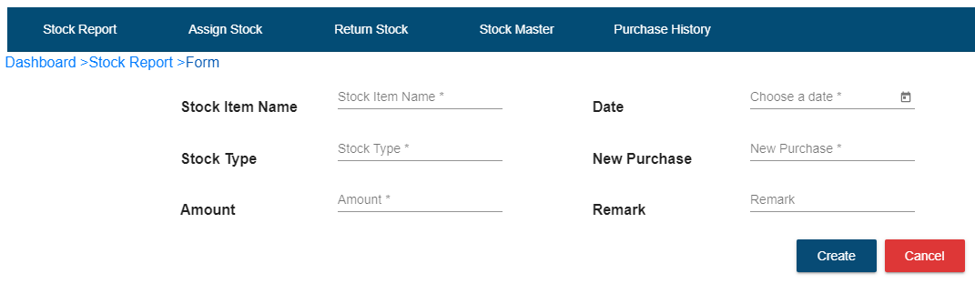

Fig. Add Stock

* After click on create button, record will save in stock report table.
* If user wants to add more stock then click on edit operation.
* Enter new purchase.
* Enter amount.
* Click on update button.

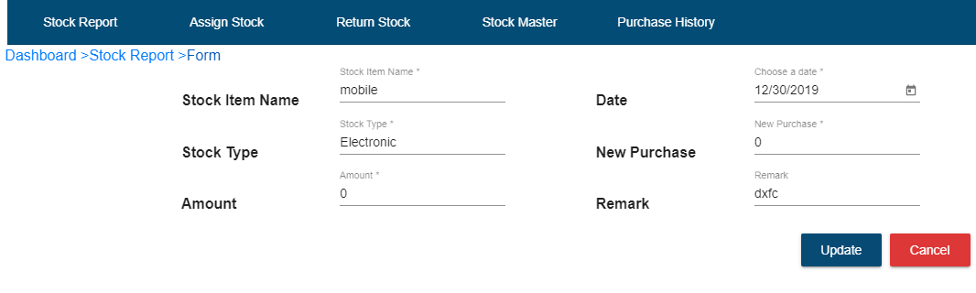

Fig. New stock

* If user wants to add same stock again and again then click on edit operation and update there.
* After adding new stock, it will display in stock report table.
* Click on date from, date to and item name.
* Click on search button
* After click on search button, record will be display.



Fig. Search Stock Record

**2. Assign Stock**

* Click on assign stock sub module.
* Click on add assign button.

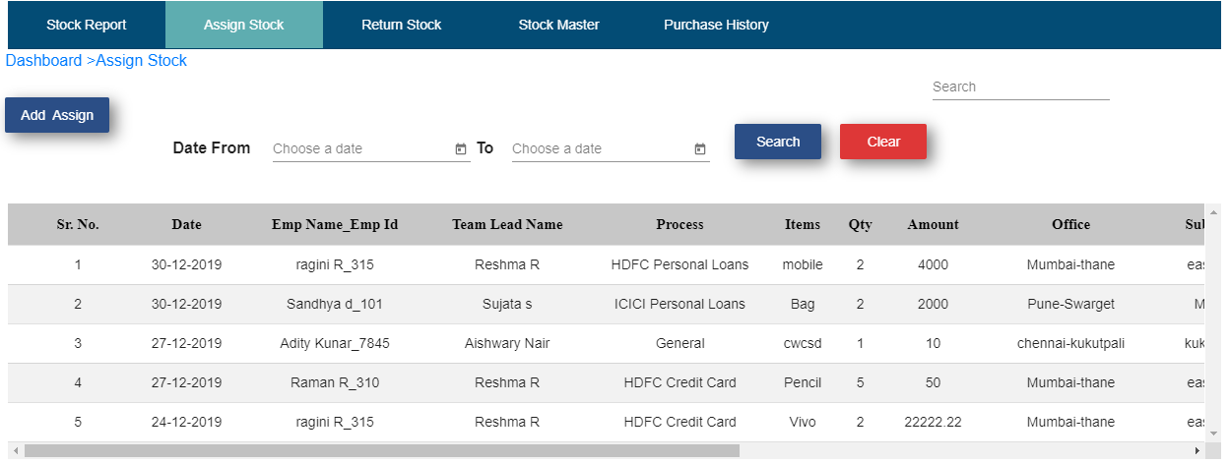

* Choose date.
* Select team manager.
* Select employee name.
* Select process.
* Select items.
* Enter quantity.
* Amount will be auto calculated.
* Office will be auto select.
* Sub office will be auto select.
* Select assigned by.
* Enter activity name.
* Click on create button.

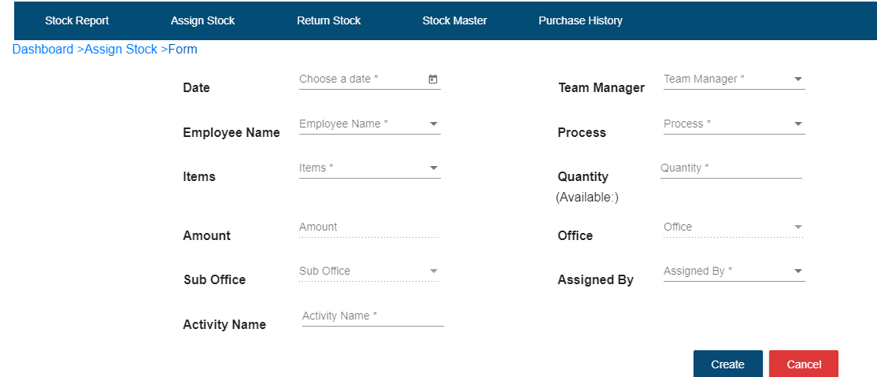

Fig. Assign Stock

* After click on create button record will be display in assign stock table.
* If user wants to see details of assigned stock then click on view details operation.

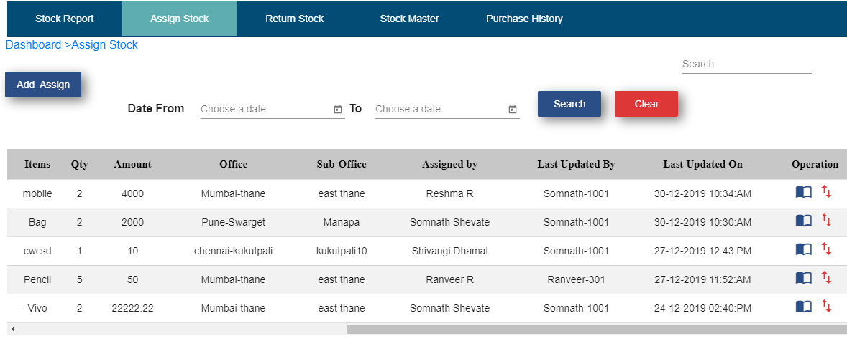

Fig. Assign Stock View Operation

* Click on date from and date to.
* Click on search button.
* After click on search button particular record will display.



Fig. Assign Stock search button

**3. Return Stock**

* Click on return stock sub module.
* Click on return stock button.

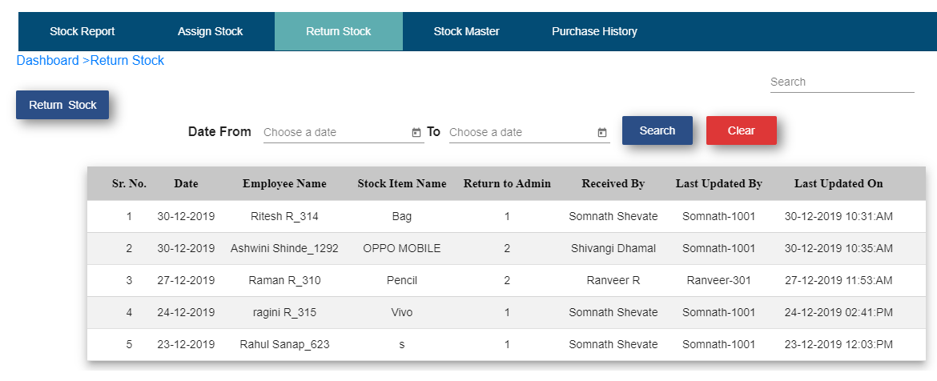

* Select employee name.
* Select stock item name.
* Enter return quantity.
* Select return date.
* Select received by.
* Click on submit button.

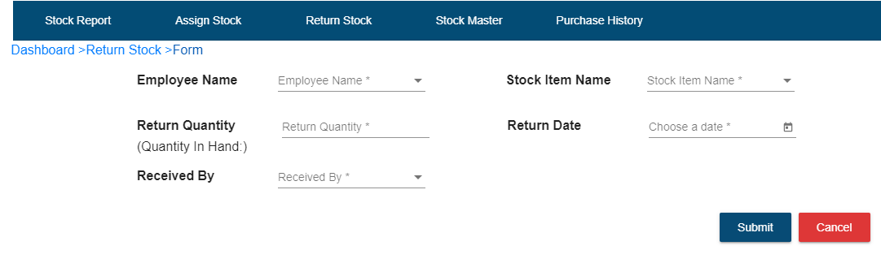Fig. Return stock

* After click on submit button record will display in return stock table.
* Select date from and date to.
* Click on search button.
* After click on search button, particular record will be display.



Fig. Return Stock Search Button

**4. Stock Master:**

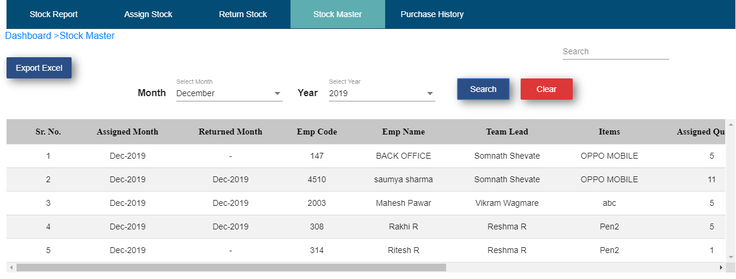

* Click on Export Excel
* Click on Export button on popup window
* Click on Ok
* Stock master report get downloaded like below mentioned sheet

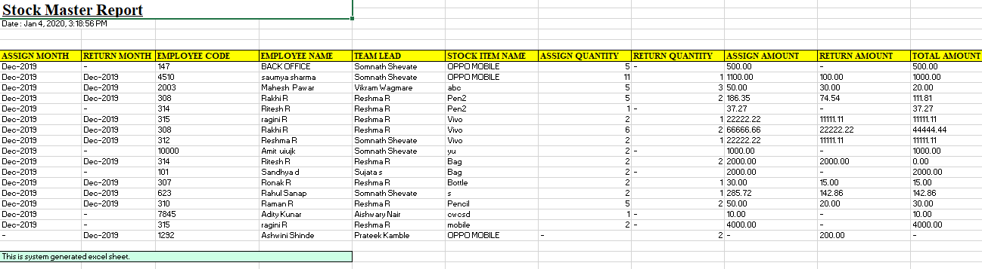

**5. Purchase History:**

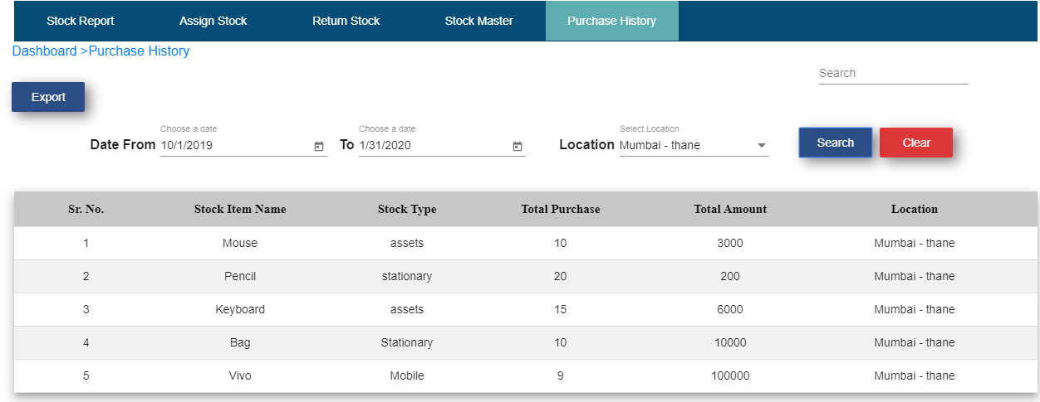

* Click on Export
* Click on Ok
* Purchase History Report get downloaded

